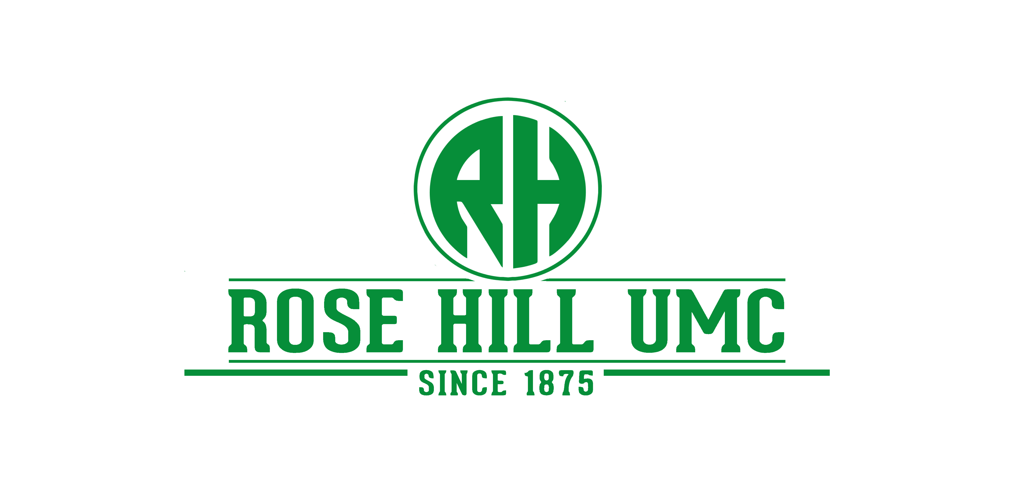

BUILDING USE POLICIES AND CONTRACT FOR OUTSIDE GROUPS

Rose Hill United Methodist Church (RHUMC) seeks to be a friendly, warm and caring church, and we hope to serve everyone in a way that demonstrates the love of Jesus Christ our Lord. The Church offers meeting and activity space to groups that serve the needs of the community and that adhere to purposes and goals consistent with the principles, doctrines, beliefs and social principles of The United Methodist Church.

Policies

Groups using RHUMC facilities shall adhere to the guidelines below. The RHUMC Board of Directors reserves the right to change these policies at any time without notice.

Priority of Building Use:

First Priority: RHUMC Ministry Events – Regularly scheduled church meetings, programs and activities

Second Priority: Other United Methodist Church-related activities

Third Priority: RHUMC member activities (not sponsored by RHUMC)
A staff person or officer of the organization must sign the building use contract. Activities with recurring dates will be reviewed at a minimum of once a year.

Last Priority: Activities sponsored by nonprofit organizations unrelated to RHUMC. A staff person or officer of the organization must sign the building use contract. Activities with recurring dates will be reviewed at a minimum of once a year.

Not Approved: Outside groups/activities engaged in fund raising, solicitation, or political campaigns or similar causes.

Scheduling an Event
The scheduling of an event is arranged through the church office by sending an email to: calendar@rosehillumc.org. Groups/organizations outside of RHUMC must complete the “Building Use Contract” and “Hold Harmless Agreement.”

Guidelines

Note: It is the responsibility of the person(s) signing the Building Use Contract to see that all persons participating in the event are informed of these Guidelines.

Special COVID-19 Guidelines

- Prior to attending any regathering, we ask everyone to self-screen for illness. If you are sick or do not feel well, please stay home.
- We ask everyone, out of love for one-another, to honor 6 ft. distancing.
- Everyone is asked to use hand sanitizer or wash their hands when they arrive.
- Coffee service and water fountains are closed.
- Bathrooms will be open, but people are encouraged to utilize a paper towel when touching door handles. Upon exiting, hand sanitizing is encouraged.
- If someone attending an activity at RHUMC, and afterwards is diagnosed with COVID-19, seek immediate medical attention as directed by your primary care physician. Notify the church at (281) 351-5356 or office@rosehillumc.org so that notification can be made to possible infected persons, i.e. contact tracing. If a positive case is recorded, Rose Hill UMC is required to report to the District Superintendent with the Texas Annual Conference.

General Guidelines

- The conduct of all persons attending programs at RHUMC is expected to be respectful of the environment of the Lord’s house.

- Alcoholic beverages, illegal substances and smoking are prohibited in RHUMC buildings and on church property. No one under the influence of alcohol or illegal substances will be allowed to participate in programs or events.

- No flammable liquids, fire producing chemicals, pyrotechnic devices, smoke generators and/or open flames in any form (with the exception of candles used in a worship setting) may be used on the church property, without the written approval of the Office Manager.

- No food or drink is allowed in the Faith Center Sanctuary.

- Athletic activities may only occur outside the buildings.

- Tables, chairs and equipment are not to be removed from the church building without express permission from the Office Manager.
- Children in attendance must be under the control of their parents or adults in charge of the activity at all times and are not permitted to roam freely in the halls or other areas on the church property.

- All nursery or early childhood childcare provided must comply with the RHUMC Safe Sanctuary Policy.

- Please be aware that your group may not be the only group in our building. Stay in the area that has been designated for your use. If you must move through the building please be mindful of others using the facilities.

- Do not use anything to hold open doors. Prior arrangements must be made for doors to be opened at non-scheduled times.

- Animals are not allowed within the buildings, with the exception of service animals.

- In rooms equipped with movable walls, these walls may only be moved by an authorized church representative.

- Do not tape or affix anything on the walls.

- At the conclusion of your event, remove any decorations, place garbage in proper containers, return any furniture that was moved to its proper place, turn out the lights, and reset A/C to 80 degrees (summer); or heat to 65 degrees (winter).

- Ensure the outside doors are locked. If you checked out a key for your meeting, please return it in the Church mailbox located in front of the Faith Center circular driveway.

Liability

- RHUMC assumes no liability for any personal property brought into the church. Every possible effort will be made to protect personal items; however, the church will not be responsible for items lost, stolen or damaged. It is imperative that money, jewelry, and other valuables not be left unattended.

- Users are responsible and assume liability for any personal injuries, personal property or damage to the facility and/or equipment. When damage/accidents requiring cleanup occurs, prompt reporting to the church office is expected. Replacement or repair will be at the discretion of the church and will meet the requirements of the church.

- A Certificate of Insurance may be requested and must be provided upon request by all outside groups to RHUMC for the purpose of covering liability and property damage or accidents that might occur on RHUMC property. RHUMC must be named as certificate holder and additional insured and the certificate delivered with the signed contract. At the discretion of the Office Manager, a damage deposit may be accepted in lieu of a Certificate of Insurance.

Additional Services

- The Office Manager will coordinate all audio/visual needs. Use of sound equipment is restricted to trained personnel approved by RHUMC.

- The Office Manager will coordinate and approve the use of any musical instrument owned by RHUMC. Use of the Sanctuary organ and piano is restricted to persons approved by the Director of Music.

- Any notice, publication or advertising of an event held at RHUMC or associated with RHUMC must be approved through the Office Manager.

Fees

With the exception of wedding events (which includes structured fees), all other groups/organizations are asked to consider providing a love offering to RHUMC to support electricity and cleaning expenses for the event/activity.

# # #

ROSE HILL UNITED METHODIST CHURCH

BUILDING USE CONTRACT – OUTSIDE GROUPS

This Building Use Agreement is made and entered into this __________day of

______________, 202___, by and between Rose Hill United Methodist Church (RHUMC)

and _________________________________________________________________.

Signing of this agreement shall constitute willingness to comply with all rules and regulations regarding the use of RHUMC as set forth in the Building Policy. Those using the church facilities must use utmost care in the use of the facilities and the actions of those attending the event, and hereby agree to protect, indemnify and hold harmless RHUMC, its officers and employees from any and all claims, liabilities, damages or rights of action directly or indirectly growing out of the use of the premises covered by this agreement. In the event of damage to church property, those using the facilities shall accept the amount of damage as estimated by the Board of Directors and shall pay for such repair and replacement costs. The undersigned individual(s) have read and understand all of the above guidelines and requirements and agree to abide by them.

I understand that the above-mentioned activity is not sponsored by RHUMC. RHUMC will not extend coverage for medical payments in the case of injury to a child, youth or adult in attendance. Obligation for any and all medical care shall be the responsibility of the individual and/or sponsor and that individual and/or sponsor shall pay costs of medical care.
Organization

___________________________________ ___________________________________
Signature Print Name

_______________________________
Date

Rose Hill United Methodist Church

_______ ______
Accepted by Approved By: (Pastor or Officer)

______
Date

ROSE HILL UNITED METHODIST CHURCH

HOLD HARMLESS AGREEMENT

This Agreement entered into this day of , 202___ by and

between Rose Hill United Methodist Church ("RHUMC") and

("Organization").

WHEREAS, RHUMC is the owner of a building located at 21022 Rose Hill Church Road, Tomball, TX 77377

WHEREAS, Organization desires to use such facilities on the terms and conditions set forth herein.

WHEREAS, THEREFORE, in consideration of the mutual promises contained herein and other good and valuable consideration, the parties hereto agree as follows:

1. RHUMC shall make available to the Organization (description of facilities)
on (dates) ___________(times) _____.

2. The Organization and the individual(s) signed below agree to indemnify and hold RHUMC, its officers, employees and members, harmless from any and all costs, loss, fees and liability including attorney’s fees arising out of or as a consequence of the Organization's use of the above described premises, building, parking facilities, or grounds on or adjacent thereto.

We, the undersigned having read the above, accept FULL INDIVIDUAL RESPONSIBILITY, LIABILITY AND INDEMNITY and will abide by the above stated Policies.

NAME ADDRESS PHONE

Signed: _________________________________ ___________________________
On behalf of Organization and its members Printed Name

________________________________________________________________________
RHUMC church member or staff representative Printed Name

